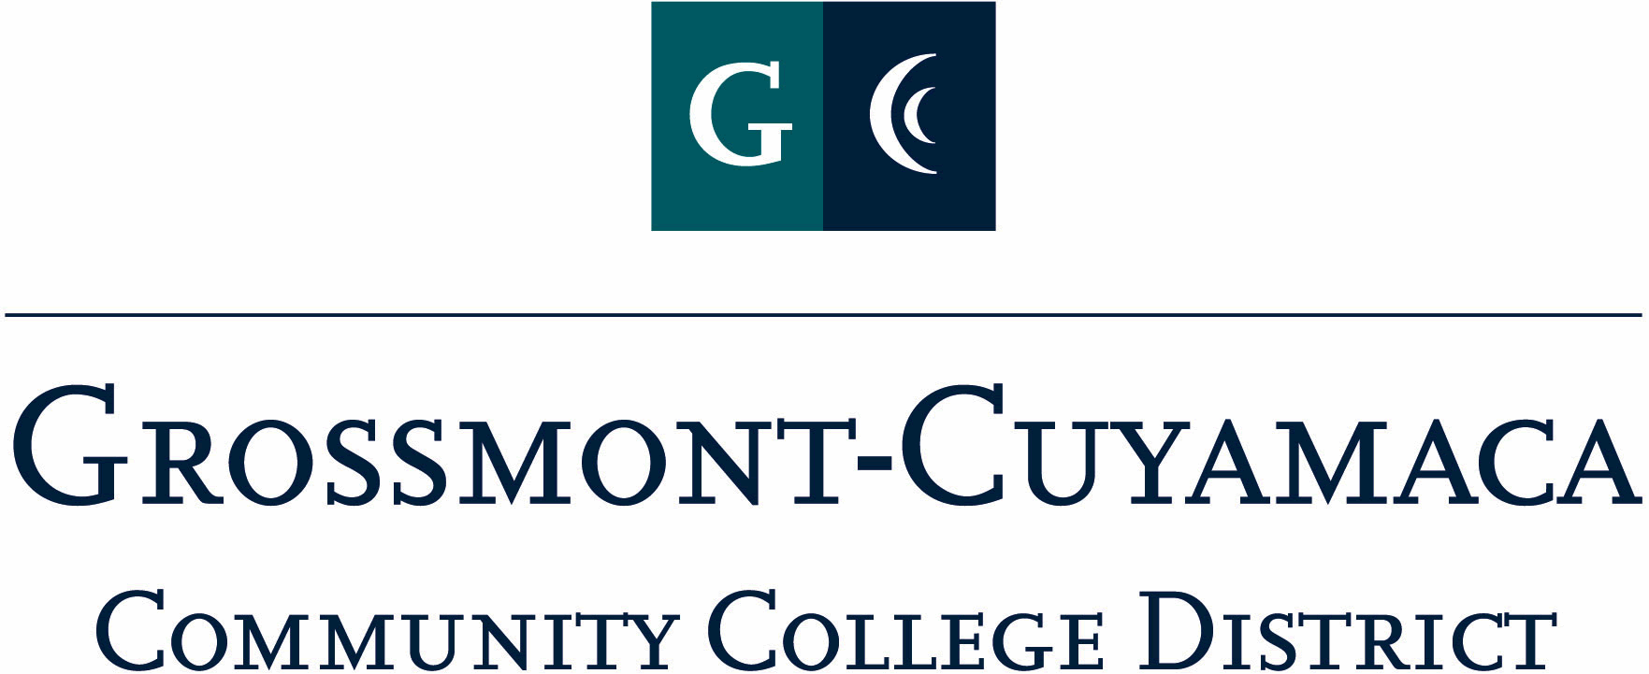
D R A F T
CLASSIFIED SENATE
EXECUTIVE BOARD MEETING
October 4, 2011 – Meeting Minutes

Members Present: Wendy Corbin, Maria Briney, Debi Miller, Avelina Mitchell (12:30), Patricia Bailey (12:40), Ken Grimes, Connie Sterling, Yvette Macy, Angela Johnson, Jennine Boschock, Nicole Boyer, Robert Mountain, Pamela Wright, Rocky Rose
Members Absent: Joe Balestreri, Jean Wallace, Pat Murray, Mary Eden, Glenn Macy, Patty Sparks
Members Excused: Melissa Chandler
Proxy Reps: JacQueline Osborne
Guests:

1. Welcome and Call to Order

The meeting was called to order at 12:02p. Videoconference equipment was not working, conducted the meeting over speaker phone.

2. Approval of Minutes from 8/2/11

The minutes from 8/2/11 meeting were approved as submitted. M/S/A Macy/Mountain.

3. Items Carried Over from Prior Meetings & 9/16 Retreat: Wendy Corbin went through the carried over items systematically as follows:

Fall Meet & Greet: CSAD Theme, Timelines & Committee Assignments: December ______
Note: Renamed to Open Membership Meeting with the 3rd Annual Ugliest Sweater Contest

Discussion: Typically an open membership meeting held at night usually as a pot luck with an ugly sweater contest. The agenda usually includes awareness (handouts) about our organization and discussion on Classified Staff Appreciation Day (CSAD) Theme and committees.

Yvette Macy stated that it is important to have some sort of meeting to get our CSAD organized, whether it be open membership or not. It is important to have this time to go over CSAD. Should we keep the same format? Night? lunch? Changing format of meeting?

Wendy Corbin added that we could possibly conduct the meeting during the day, but it would shorter, maybe for an hour. The idea of the Meet & Greet is to meet folks and have face time with the Board and then include discussion on CSAD.

Nicole Boyer suggested tying this event to a fundraiser, for instances offer pizza ($2.00) and soda ($.50) to raise money and lighten up to focus on meet & greet.

Yvette Macy added to vote on whether to have a meet & greet, even ½ the board shows up. Wendy Corbin stated there is a need to give membership an opportunity. Yvette Macy suggested that if we could agree on date and time and then discuss what to do at the event. Jennine Boschock asked if the event could be held the 2nd week in December? Determine the date we will have a meet & greet on and then sort out the details of the meet and greet as it gets closer. Rocky Rose suggested expanding the lunch hour time so that it covers every ones lunch hour, for early and late lunch rather than just keeping it 12-1. There are many people that can’t leave office at that time. Set up shifts.

Motion to hold the Meet & Greet on Tuesday, December 13, 2011 from 11:30a-1:30p at Cuyamaca College in I-209. M/S/A Boyer/Boschock. Motion passes.

Annual Organization Meeting - March ____ or _____: Agenda: _______ & CSAD
Motion: Approve March ______, 2012 as the date for the Annual Organizational Meeting.

Discussion: Wendy Corbin explained that the Annual Organization Meeting is a requirement of business. It is typically held in the evening and usually pot luck style. Yvette Macy suggested that this meeting be held after hours so we can tie up any loose ends with CSAD. Debi Miller stated that one of the points brought up at the CSAD debrief meeting that the Annual Organization Meeting should be held more than 2 weeks out from that event.

Motion to hold the Annual Organization Meeting on March 8, 5:30p-7:30p at the District Services site. M/S/A Macy/Johnson. Motion passes.

Wendy Corbin reminded the group that at the September 16 Retreat the original motion was amended by Patty Bailey that the funds be earmarked for needy children.

$100 donation for 3 children for Tecate Children.
Motion: Approve a donation of up to $100 to support 3 children for Tecate Children Donation.
Motion to table this item to October E-Board meeting. M/S/A Mitchell/Sparks. Motion passes.

Discussion: Is there something in writing, a verification of what needy is or some way of verifying the organization? For instance, does the organization have a 501c status, non-profit status paperwork, or a form that is completed by someone? Angela Johnson suggested that a request be submitted as a confidential document.

Motion to donate up to $100 to support needy children. M/S/A Mitchell/Sparks. 1 abstention. Motion passes.

$200 (cash or gift) to District Foundation (Auxiliary) $100 for CC/$100 for GC
Motion: Approve $200 to District foundation in cash or gift. M/S/A _____/____ Motion ________
Discussion: Nicole Boyer suggested the motion to give the $200 be for a gift, not in cash, for instance purchase tickets to the theater and donate back to department. Rocky Rose: can it be earmarked perhaps toward students and students’ success or something else.
Motion to approve $200 to go to the District Foundation in cash or gift. M/S/A Briney/________. Motion passes.
Motion: Approve $100 to 4CS for a Senate Level donation
M/S/A _______/_______ Motion _______.
Discussion: Colleges/Districts can give donations and recognized it is a way of keeping 4CS viable. Offer support to our grass roots state organization. M/S/A Mountain/Miller. 5 yes, 3 opposed, 3 abstentions. Motion passes.
Motion: Approve the release of at least 10% of net profits from fundraising efforts otherwise not designated and split equally between the two colleges for student needs and request submitted by written proposal. Note: A draft of the proposal form will be presented at the October meeting for a 1st read along with submittal timelines and ranking process. M/S/A _____/______ Motion _______.
Wendy: Did we visit this motion? I don’t have anything in my notes – sorry……
Motion: Approve the support of [____ (#)] continuing or incoming senate officers to attend the 2012 Classified Leadership Institute (to include registration and room). {Scheduled on June 14-16 at Crowne Plaza, Ventura CA} Note: A draft scholarship form will be presented for a 1st read at the October meeting along with submittal timelines. M/S/A _______/______ Motion _______.

Motion to table. M/S/A Miller/Mountain. Motion passes.

4. Communication

VP Reports

District: Time ran out.

Grossmont: Time ran out.

Cuyamaca: Time ran out.

President’s Report: Wendy Corbin informed the group that she would be sending out a draft of the newsletter for the E-Board to review and weigh in on.

Treasurer Report: Time ran out.

4. Continuing Business: Time ran out.

5. Fundraising Activities: Time ran out.

6. Governance: Time ran out.

7. New Business: Time ran out.

The speaker phone disconnected at 1:02p.

